Packet Tracer – Configure Layer 3 Switching and Inter-VLAN Routing

1. Topology

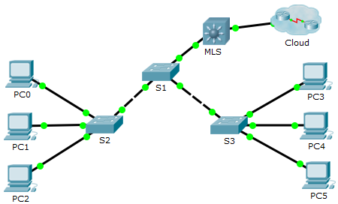

1. Addressing Table

|  |  |  |  |
| --- | --- | --- | --- |
| Device | Interface | IP Address | Subnet Mask |
| MLS | VLAN 10 | 192.168.10.254 | 255.255.255.0 |
| VLAN 20 | 192.168.20.254 | 255.255.255.0 |
| VLAN 30 | 192.168.30.254 | 255.255.255.0 |
| VLAN 99 | 192.168.99.254 | 255.255.255.0 |
| G0/2 | 209.165.200.225 | 255.255.255.252 |
| PC0 | NIC | 192.168.10.1 | 255.255.255.0 |
| PC1 | NIC | 192.168.20.1 | 255.255.255.0 |
| PC2 | NIC | 192.168.30.1 | 255.255.255.0 |
| PC3 | NIC | 192.168.10.2 | 255.255.255.0 |
| PC4 | NIC | 192.168.20.2 | 255.255.255.0 |
| PC5 | NIC | 192.168.30.2 | 255.255.255.0 |
| S1 | VLAN 99 | 192.168.99.1 | 255.255.255.0 |
| S2 | VLAN 99 | 192.168.99.2 | 255.255.255.0 |
| S3 | VLAN 99 | 192.168.99.3 | 255.255.255.0 |

1. Objectives

Part 1: Configure Layer 3 Switching

Part 2: Configure Inter-VLAN Routing

1. Background / Scenario

A multilayer switch like the Cisco Catalyst 3560 is capable of both Layer 2 switching and Layer 3 routing. One of the advantages of using a multilayer switch is this dual functionality. A benefit for a small- to medium-sized company would be the ability to purchase a single multilayer switch instead of separate switching and routing network devices. Capabilities of a multilayer switch include the ability to route from one VLAN to another using multiple switched virtual interfaces (SVIs), as well as the ability to convert a Layer 2 switchport to a Layer 3 interface.

1. Configure Layer 3 Switching

In Part 1, you will configure the GigabitEthernet 0/2 port on switch MLS as a routed port and verify that you can ping another Layer 3 address.

* + - 1. On MLS, configure G0/2 as a routed port and assign an IP address according to the Addressing Table.

MLS(config)# **interface g0/2**

MLS(config-if)# **no switchport**

MLS(config-if)# **ip address 209.165.200.225 255.255.255.252**

* + - 1. Verify connectivity to **Cloud** by pinging 209.165.200.226.

MLS# **ping 209.165.200.226**

Type escape sequence to abort.

Sending 5, 100-byte ICMP Echos to 209.165.200.226, timeout is 2 seconds:

!!!!!

Success rate is 100 percent (5/5), round-trip min/avg/max = 0/0/0 ms

1. Configure Inter-VLAN Routing
   * 1. Add VLANs.

Add VLANs to MLS according to the table below.

|  |  |
| --- | --- |
| VLAN Number | VLAN Name |
| 10 | Staff |
| 20 | Student |
| 30 | Faculty |

* + 1. Configure SVI on MLS.

Configure and activate the SVI interface for VLANs 10, 20, 30, and 99 according to the Addressing Table. The configuration for VLAN 10 is shown below.

MLS(config)# **interface vlan 10**

MLS(config-if)# **ip address 192.168.10.254 255.255.255.0**

* + 1. Enable routing.
       1. Use the **show ip route** command. Are there any active routes? No Ninguno

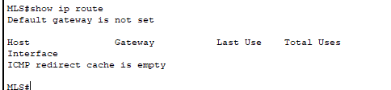

* + - 1. Enter the **ip routing** command to enable routing in global configuration mode.

MLS(config)# **ip routing**

* + - 1. Use the **show ip route** command to verify routing is enabled.

MLS# **show ip route**

Codes: C - connected, S - static, I - IGRP, R - RIP, M - mobile, B - BGP

D - EIGRP, EX - EIGRP external, O - OSPF, IA - OSPF inter area

N1 - OSPF NSSA external type 1, N2 - OSPF NSSA external type 2

E1 - OSPF external type 1, E2 - OSPF external type 2, E - EGP

i - IS-IS, L1 - IS-IS level-1, L2 - IS-IS level-2, ia - IS-IS inter area

* - candidate default, U - per-user static route, o - ODR

P - periodic downloaded static route

Gateway of last resort is not set

C 192.168.10.0/24 is directly connected, Vlan10

C 192.168.20.0/24 is directly connected, Vlan20

C 192.168.30.0/24 is directly connected, Vlan30

C 192.168.99.0/24 is directly connected, Vlan99

209.165.200.0/30 is subnetted, 1 subnets

C 209.165.200.224 is directly connected, GigabitEthernet0/2

* + 1. Verify end-to-end connectivity.
       1. From PC0, ping PC3 or MLS to verify connectivity within VLAN 10.

PC0 a PC3

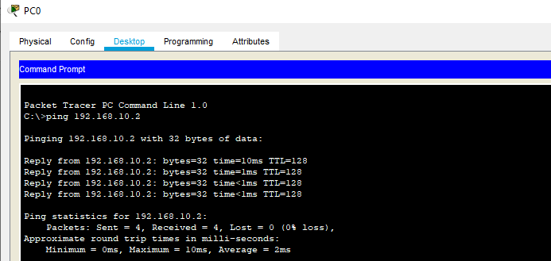

PC0 a MLS

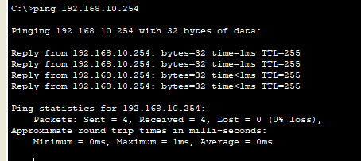

* + - 1. From PC1, ping PC4 or MLS to verify connectivity within VLAN 20.

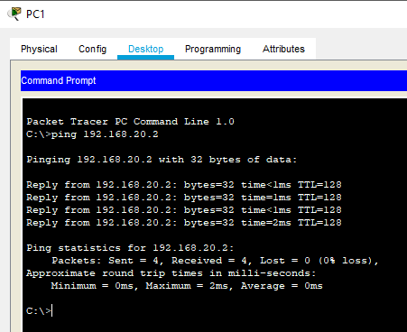

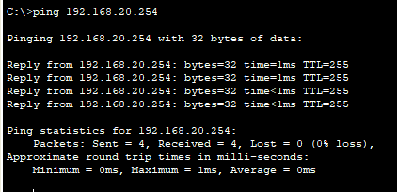

* + - 1. From PC2, ping PC5 or MLS to verify connectivity within VLAN 30.

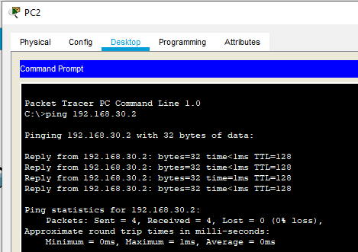

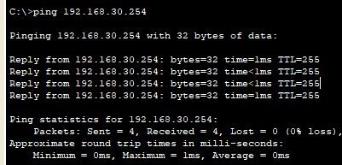

* + - 1. From S1, ping S2, S3, or MLS to verify connectivity with VLAN 99.

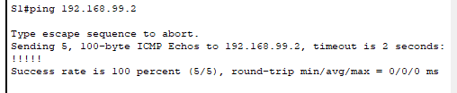

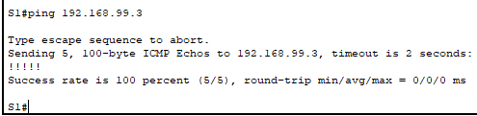

* + - 1. To verify inter-VLAN routing, ping devices outside the sender’s VLAN

De la vlan 20 a la vlan 30

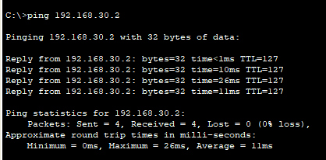

.

* + - 1. From any device, ping this address inside **Cloud**, 209.165.200.22

